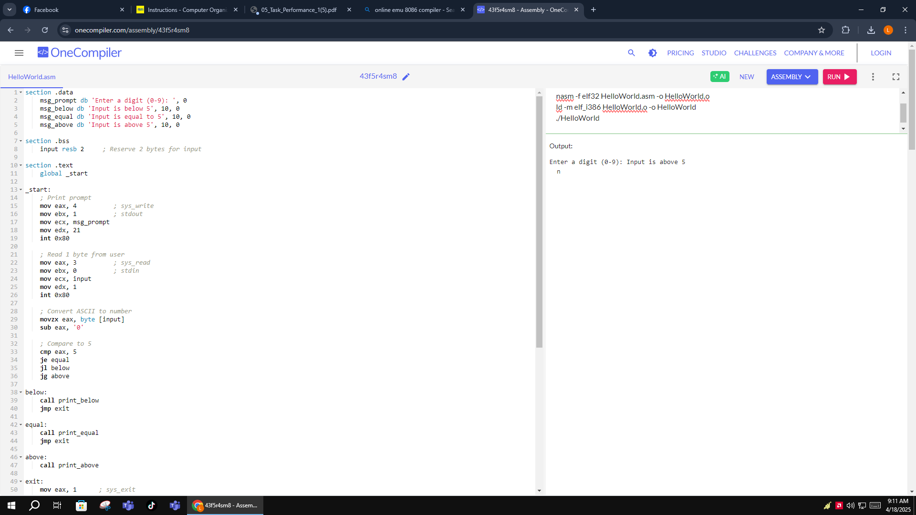

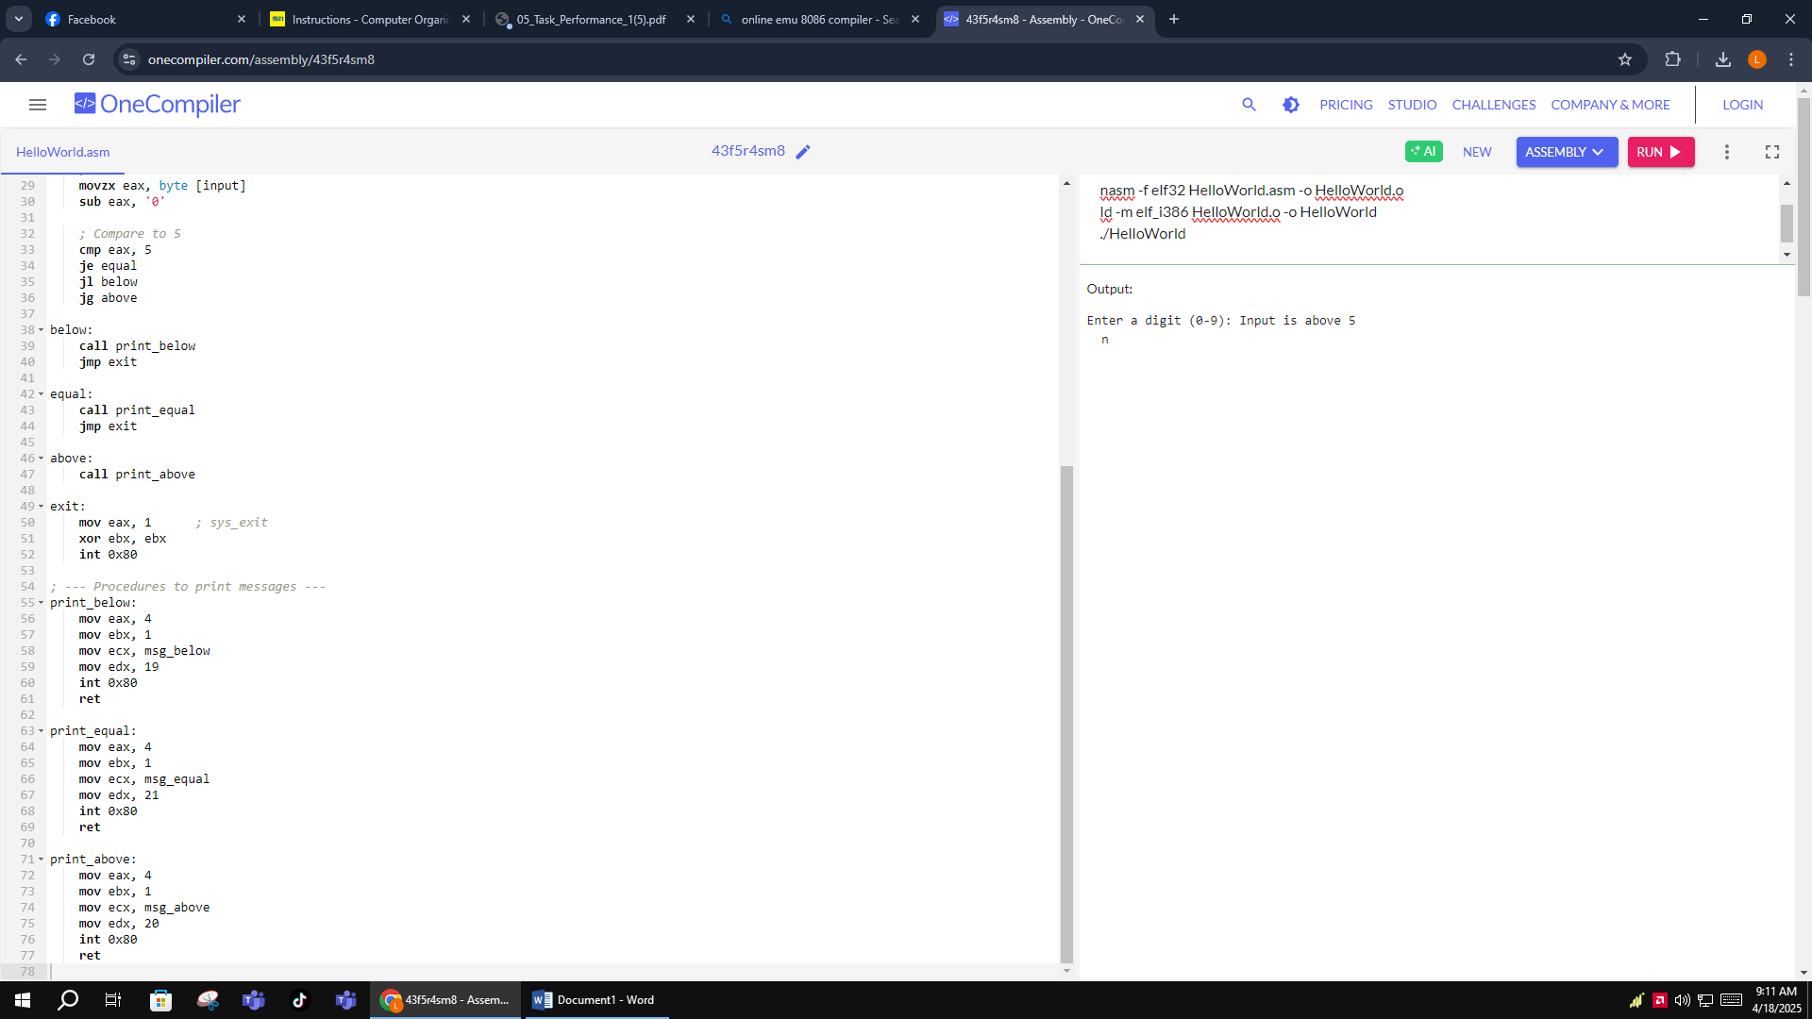

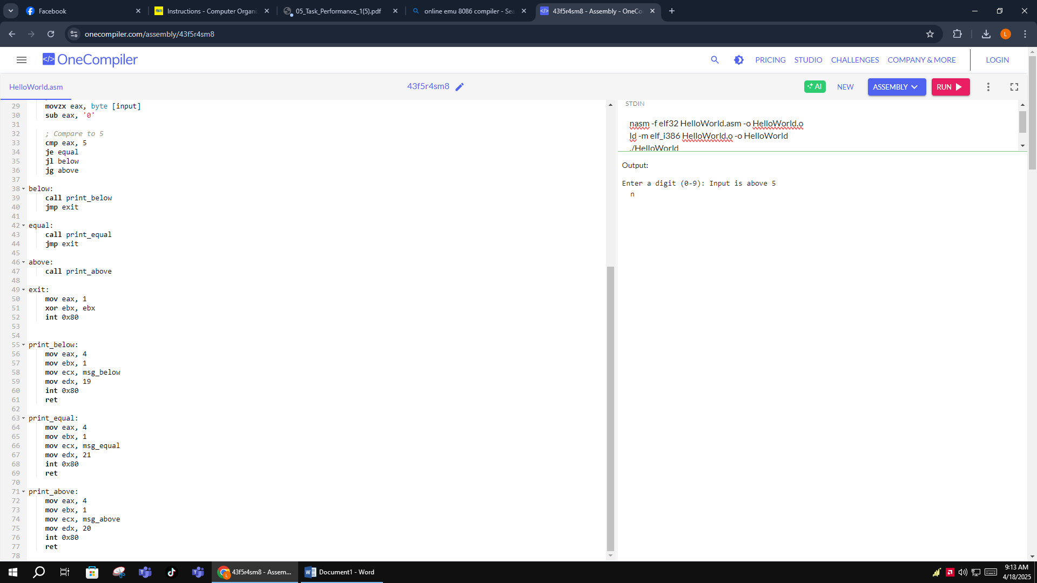

section .data

msg_prompt db 'Enter a digit (0-9): ', 0

msg_below db 'Input is below 5', 10, 0

msg_equal db 'Input is equal to 5', 10, 0

msg_above db 'Input is above 5', 10, 0

section .bss

input resb 2 ; Reserve 2 bytes for input

section .text

global _start

_start:

; Print prompt

mov eax, 4 ; sys_write

mov ebx, 1 ; stdout

mov ecx, msg_prompt

mov edx, 21

int 0x80

; Read 1 byte from user

mov eax, 3 ; sys_read

mov ebx, 0 ; stdin

mov ecx, input

mov edx, 1

int 0x80

; Convert ASCII to number

movzx eax, byte [input]

sub eax, '0'

; Compare to 5

cmp eax, 5

je equal

jl below

jg above

below:

call print_below

jmp exit

equal:

call print_equal

jmp exit

above:

call print_above

exit:

mov eax, 1

xor ebx, ebx

int 0x80

print_below:

mov eax, 4

mov ebx, 1

mov ecx, msg_below

mov edx, 19

int 0x80

ret

print_equal:

mov eax, 4

mov ebx, 1

mov ecx, msg_equal

mov edx, 21

int 0x80

ret

print_above:

mov eax, 4

mov ebx, 1

mov ecx, msg_above

mov edx, 20

int 0x80

ret

**EXPLANATION OF THE PROGRAM**

The three primary sections of the program are text, bss, and data. Predefined strings used for output and prompting messages are stored in the.data section. The user's input is reserved in the.bss section. The application begins by reading a single-digit character from the user and displaying a prompt in the.text section. After that, it uses the cmp instruction to convert the ASCII input into a numeric value and compare it to 5. It jumps to the relevant label to invoke a particular procedure (print_below, print_equal, or print_above) based on the comparison. Every procedure prints its message using a system call, and the program terminates with an exit syscall.